**Introduction**

Global Computer Solutions (GCS), an information technology consulting company, is well known for its ability to match highly skilled employees with projects according to the region. To better manage its project, GCS has contacted me for a database design so GCS managers can keep track of their customers, employees, projects, project schedules, assignment and invoices. The interview process yields the following business rules:

1. GCS Employees must have employee ID, last name, a middle initial, a first name, a region and a hire date.
2. Regions have the following vales: Northwest (NW), Southwest (SW), Midwest North (MN), Midwest South (MS), Northeast (NE), and Southeast (SE).
3. Each employee has many skills, and many employees have the same skill.
4. Each skillhas a skill ID, description and pay rate.
5. Skill values are: Data Entry I, Data Entry II, Systems Analyst I, Systems Analyst II, Database Designer I, Database Designer II, Cobol I, Cobol II, C++ I, C++ II, VB I, VB II, ColdFusion I, ColdFusion II, ASP I, ASP II, Oracle DBA, MS SQL Server DBA, Network Engineer I, Network Engineer II, Web Administrator, Technical Writer, and Project Manager.
6. Each customer has a customer ID, name, phone number, and region.
7. Each Project has the project ID, the customer to which the project belongs, a brief description, a project date (the date the contract was signed), an estimated project start date, end date and budget, an actual start date, end date, and cost, and one employee assigned as the manager of the project.
8. The actual cost is computed by adding week’s cost to the actual cost and updated every Friday. The week’s cost is computed by multiplying the hours each employee worked by the rate of pay for that skill.
9. Manager determines the tasks that will be performed to take the project from beginning to end in project schedule. Each task has a task ID, a brief task description, starting and ending dates, the types of skills needed, and the number of employees (with the required skills) needed to complete the task.
10. Tasks are: initial interview, database and system design, implementation, coding, testing, and final evaluation and sign-off.
11. Each project schedule task can have many employees assigned to it, and a given employee can work on multiple project tasks. However, an employee can work on only one project task at a time.
12. Assignment has: assignment ID, employee, project schedule task, assignment start date, and assignment end date.
13. Work log contains a record of the actual hours worked by employees on a given assignment. The form contains the date, which is either the current Friday of the month or the last workday of the month if it does not fall on a Friday. The form also contains the assignment ID, the total hours worked either that week or up to the end of the month, and the bill number to which the work-log entry is charged.
14. Each work-log entry can be related to only one bill.
15. Bill is sent to the customer for total hours worked on the project in every 15 days.
16. A bill can refer to many work-log entries, and each work log entry can be related to only one bill.

**Entity Relationship Diagram**

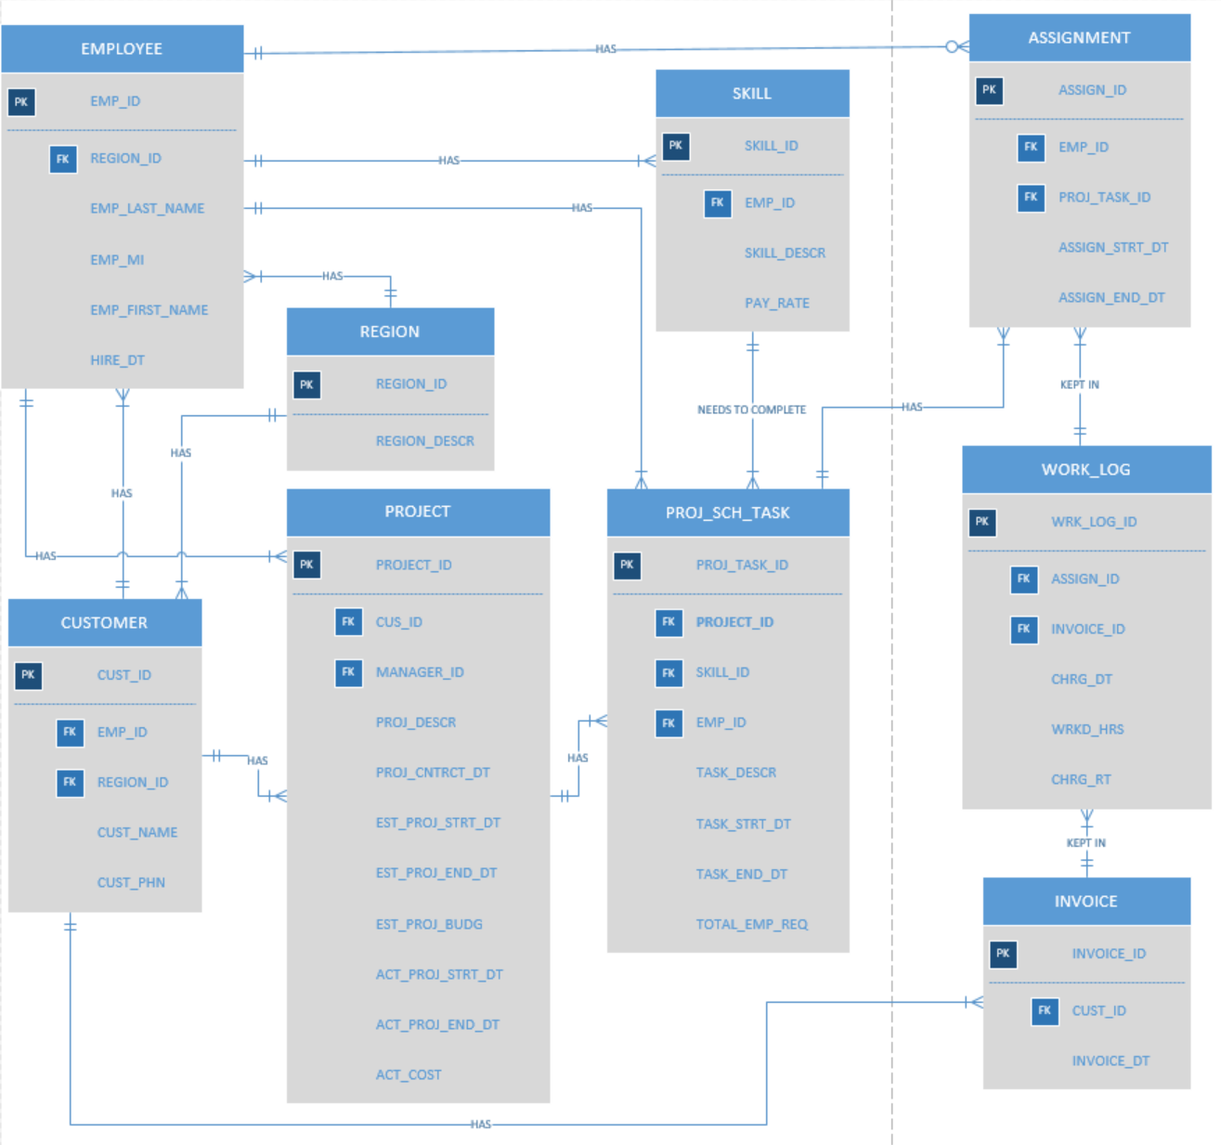

**Relational Model**

EMPLOYEE (**EMP_ID**, *REGION_ID*, EMP_LAST_NAME, EMP_MI, EMP_FIRST_NAME, HIRE_DT)

REGION (**REGION_ID**, REGION_DESCR)

SKILL (**SKILL_ID**, *EMP_ID*, SKILL_DESCR, PAY_RATE)

ASSIGNMENT (**ASSIGN_ID**, *EMP_ID, PROJ_TASK_ID*, ASSIGN_STRT_DT, ASSIGN_END_DT)

CUSTOMER (**CUST_ID**, *EMP_ID, REGION_ID*, CUST_NAME, CUST_PHN)

PROJECT (**PROJECT_ID**, *CUST_ID, MANAGER_ID*, PROJ_DESCR, PROJ_CNTRCT_DT, EST_PROJ_STRT_DT, EST_PROJ_END_DT, EST_PROJ_BUDG, ACT_PROJ_STRT_DT, ACT_PROJ_END_DT, ACT_COST)

PROJ_SCH_TASK (**PROJ_TASK_ID**, *PROJECT_ID, SKILL_ID, EMP_ID*, TASK_DESCR, TASK_STRT_DT, TASK_END_DT, TOTAL_EMP_REQ)

WORK_LOG (**WRK_LOG_ID**, *ASSIGN_ID, INVOICE_ID*, CHRG_DT, WRKD_HRS, CHRG_RT)

INVOICE (**INVOICE_ID**, *CUST_ID*, BILL_DT)

**Data Dictionary**

|  |  |  |  |  |  |  |
| --- | --- | --- | --- | --- | --- | --- |
| **ENTITY**  **NAME** | **ATTRIBUTE**  **NAME** | **DESCRIPTION** | **DATA TYPE** | **REQ** | **PK OR FK** | **FK REFERENCE TABLE** |
| EMPLOYEE | EMP_ID | Employee ID | INT(6) | Y | PK |  |
|  | REGION_ID | Region ID | CHAR(2) | Y | FK | REGION |
|  | EMP_LAST_NAME | Last Name | VARCHAR(20) | Y |  |  |
|  | EMP_MI | Middle Name | CHAR(1) | Y |  |  |
|  | EMP_FIRST_NAME | First Name | VARCAHR(20) | Y |  |  |
|  | HIRE_DT | Hire Date | DATE | Y |  |  |
| REGION | REGION_ID | Region ID | CHAR(2) | Y | PK |  |
|  | REGION_DESCR | Region Description | VARCHAR(20) | Y |  |  |
| SKILL | SKILL_ID | Skill ID | VARCHAR(6) | Y | PK |  |
|  | EMP_ID | Employee ID | INT(6) | Y | FK | EMPLOYEE |
|  | SKILL_DESCR | Skill Description | VARCHAR(40) | Y |  |  |
|  | PAY_RATE | Pay Rate | DECIMAL(7,2) | Y |  |  |
| ASSIGNMENT | ASSIGN_ID | Assignment ID | VARCHAR(6) | Y | PK |  |
|  | EMP_ID | Employee ID | INT(6) | Y | FK | EMPLOYEE |
|  | PROJ_TASK_ID | Project task ID | VARCHAR(6) | Y | FK | PROJ_SCH_TASK |
|  | ASSIGN_STRT_DT | Assignment Start Date | DATE |  |  |  |
|  | ASSIGN_END_DT | Assignment End Date | DATE |  |  |  |
| CUSTOMER | CUST_ID | Customer ID | VARCHAR(6) | Y | PK | CUSTOMER |
|  | EMP_ID | Employee ID | INT(6) | Y | FK | EMPLOYEE |
|  | REGION_ID | Region ID | CHAR(2) | Y | FK | REGION |
|  | CUST_NAME | Customer ID | VARCHAR(20) | Y |  |  |
|  | CUST_PHN | Customer Phone | VARCHAR(15) | Y |  |  |
| PROJECT | PROJECT_ID | Project ID | VARCHAR(6) | Y | PK |  |
|  | CUST_ID | Customer ID | VARCHAR(6) | Y | FK | CUSTOMER |
|  | MANAGER_ID | Manager ID | INT(6) | Y | FK | EMPLOYEE |
|  | PROJ_DESCR | Project Description | VARCHAR(40) | Y |  |  |
|  | PROJ_CNTRCT_DT | Contract date | DATE | Y |  |  |
|  | EST_PROJ_STRT_DT | Estimate Project Start Date | DATE | Y |  |  |
|  | EST_PROJ_END_DT | Estimate Project End Date | DATE | Y |  |  |
|  | EST_PROJ_BUDG | Estimate Project Budget | DECIMEL(9,2) | Y |  |  |
|  | ACT_PROJ_STRT_DT | Actual Project Start Date | DATE | Y |  |  |
|  | ACT_PROJ_END_DT | Actual Project End Date | DATE | Y |  |  |
|  | ACT_COST | Actual Project Cost | DECIMEL(9,2) | Y |  |  |
| PROJ_SCH_TASK | PROJ_TASK_ID | Project Task ID | VARCHAR(6) | Y | PK |  |
|  | PROJECT_ID | Project ID | VARCHAR(6) | Y | FK | PROJECT |
|  | SKILL_ID | Skill ID | VARCHAR(6) | Y | FK | SKILL |
|  | EMP_ID | Employee ID | INT(6) | Y | FK | EMPLOYEE |
|  | TASK_DESCR | Task Description | VARCHAR(40) | Y |  |  |
|  | TASK_STRT_DT | Task Start Date | DATE | Y |  |  |
|  | TASK_END_DT | Task End Date | DATE | Y |  |  |
|  | TOTAL_EMP_REQ | Total Employee Required | INT(4) | Y |  |  |
| WORK_LOG | WRK_LOG_ID | Work Log ID | VARCHAR(6) | Y | PK |  |
|  | ASSIGN_ID | Assignment ID | VARCHAR(6) | Y | FK | ASSIGNMENT |
|  | INVOICE_ID | Invoice ID | VARCHAR(6) | Y | FK | INVOICE |
|  | CHRG_DT | Charge Date | DATE | Y |  |  |
|  | WRKD_HRS | Hours Worked | DECIMEL(4,2) | Y |  |  |
|  | CHRG_RT | Charge Rate | DECIMEL(9,2) | Y |  |  |
| INVOICE | INVOICE_ID | Invoice ID | VARCHAR(6) | Y | PK |  |
|  | CUST_ID | Customer ID | VARCHAR(6) | Y | FK | CUSTOMER |
|  | INVOICE_DT | Invoice Date | DATE | Y |  |  |

**Appendix**

